Code Review: I2310304
Reviewer: James Wood
Date: December 8th, 2023

Bugs

Preventative Action/Safety

Design/Architecture (Duplication, appropriate project, namespaces, maintainability)

Data Model (Naming, good design, needs index?)

Performance (Minimize DB hits, excessive loops, queries, scalable)

UI (Alignment, naming, standardization, tab order)

Error Handling (Behind events, appropriate parameter checking)

Cleanup (Dispose code, remove handlers, large data objects)

Readability (Well-named variables, methods, clear algorithm, is it understandable)
- It looks like this variable is being referenced before it gets set:
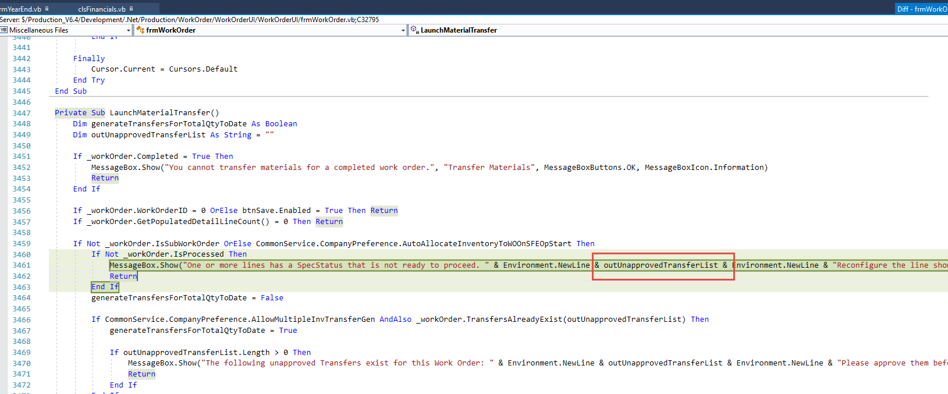

Comments (Useful, explains why rather than how)
- Is there a reason new, commented out code was checked in?
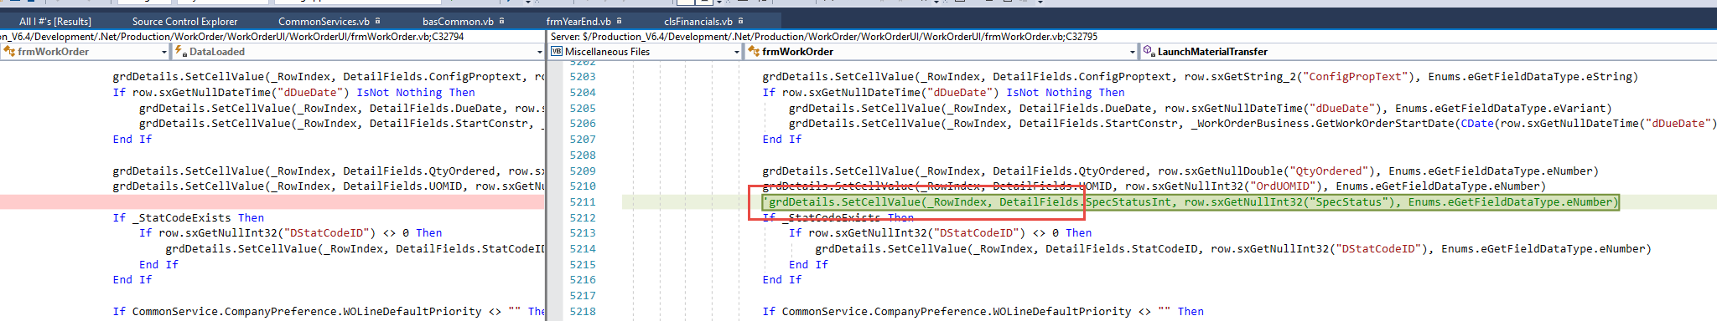

Message Boxes (Grammar, spelling, captions, appropriate icons)
- Grammar check:
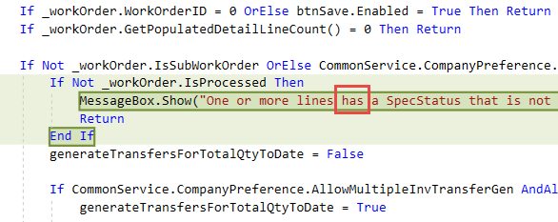
In the above message box I think I’d also split up SpecStatus to be “Spec Status” to be more visually appealing to the user. Note, Shawn has mentioned to me in the past that one of his pet peeves is column headers having no spaces, “SalesOrderNo” vs. “Sales Order No”.
- Nit: The sentence feels a little awkward, “One or more lines [have] a [Spec Status] that is not ready to proceed”. Is it the Spec Status that isn’t ready to proceed or the line/item itself? I think it might be a little clearer like this, “One or more lines have a Spec Status of Not Ready to Proceed.”
- I’d put an (s) after “line” => “Reconfigure the line(s)…”:
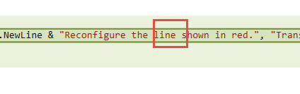
- Nit: Perhaps we should make these all consistent.
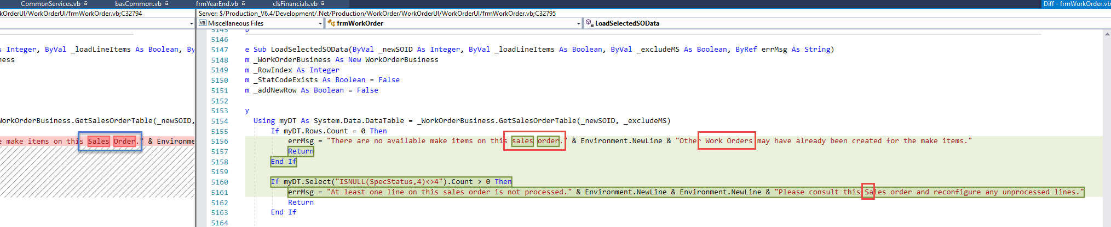

Ticket Management (Release Branch?, Testing Notes)

Extras

